"**Comprehensive CRM Analysis: Insights from Five Key Datasets in SQL"**

Snehal Jadhav | CRM | 3/2/2024

Data sets

create database CRM;

use CRM;

select * from accounts;

select * from clicks;

select * from products;

SELECT * FROM crm.`sales-pipeline`;

select * from `sales-teams`;

"Comprehensive CRM Analysis: Insights from Five Key Datasets in SQL" offers an in-depth exploration of customer relationship management (CRM) data through the lens of SQL-driven analysis. This report synthesizes findings from five critical datasets, providing a holistic view of customer interactions, sales performance, account management, and product engagement within the CRM ecosystem. By leveraging advanced SQL queries, the report uncovers patterns, trends, and actionable insights that can drive strategic decisions and enhance customer engagement strategies. Through meticulous data examination and interpretation, this analysis serves as a valuable resource for understanding the dynamics of CRM data and optimizing business outcome

1 SELECT Clause: Find the names of all products.

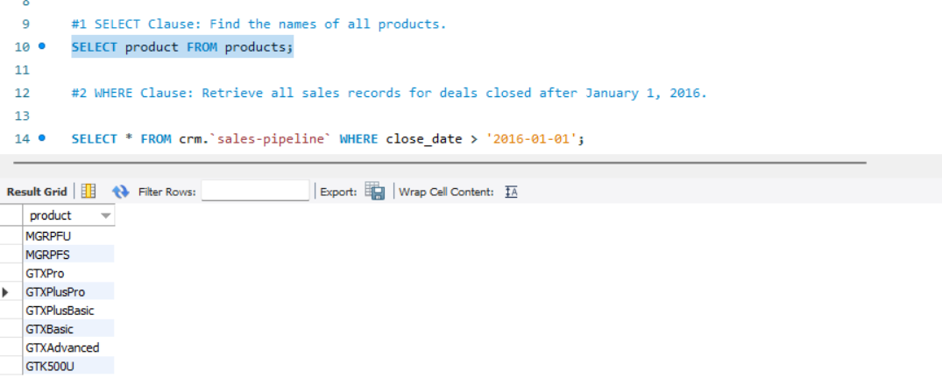

2 WHERE Clause: Retrieve all sales records for deals closed after January 1, 2016.

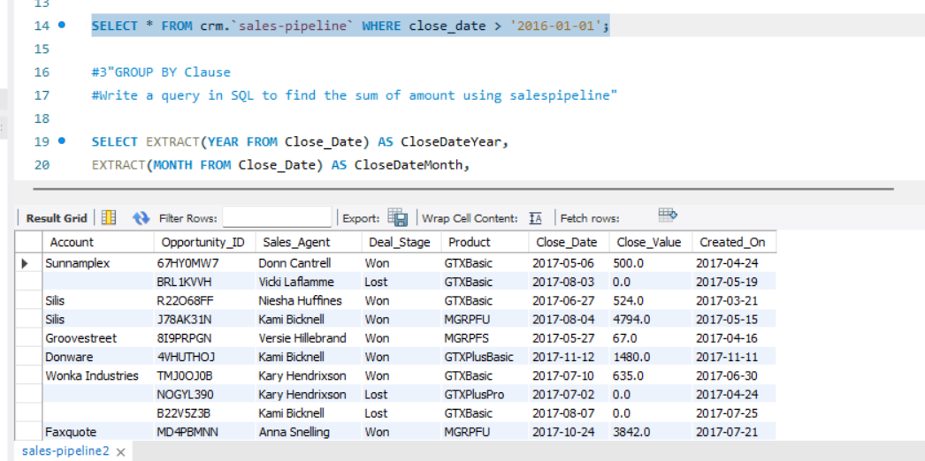

3 Write a query in SQL to find the sum of amount using salespipeline"

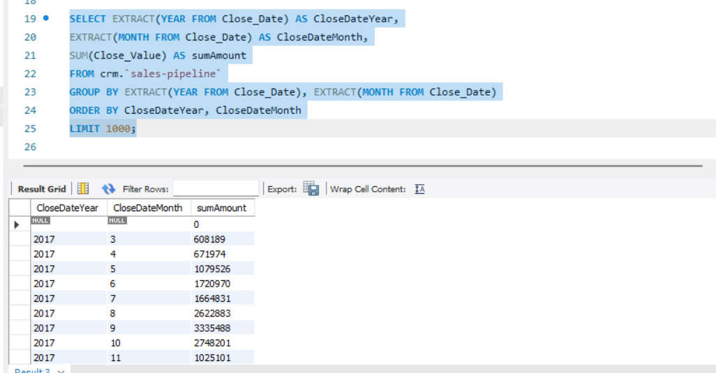

4 Write a query in SQL to obtain the name of the account with Opportunity_ID who are yet to be affiliated."

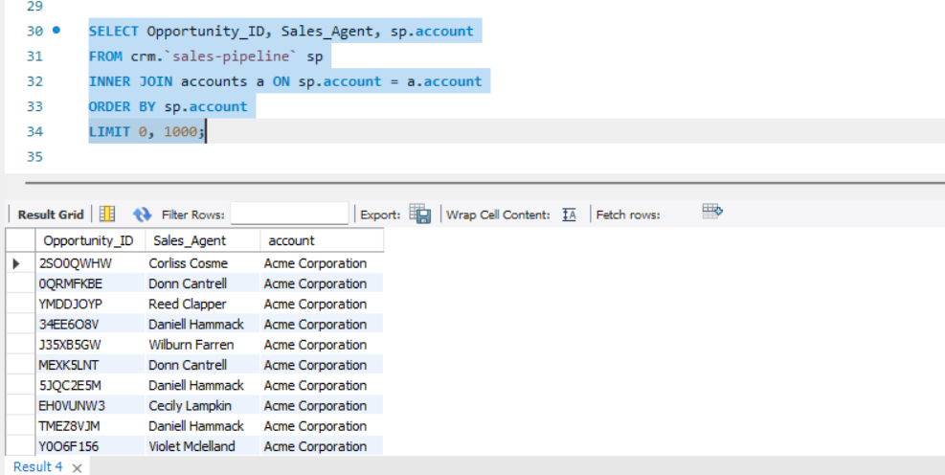

5 Write a query in SQL Count the number of sales team members for each regional office and display only those with more than 5 members.

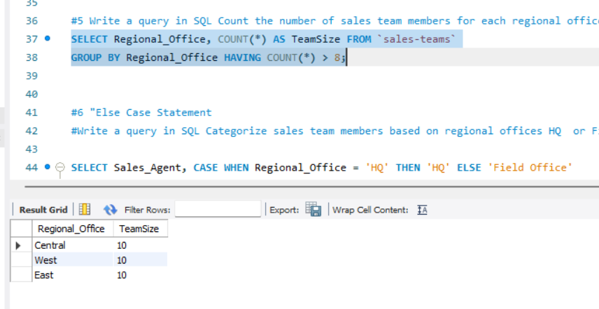

6 Write a query in SQL Categorize sales team members based on regional offices HQ or Field office"

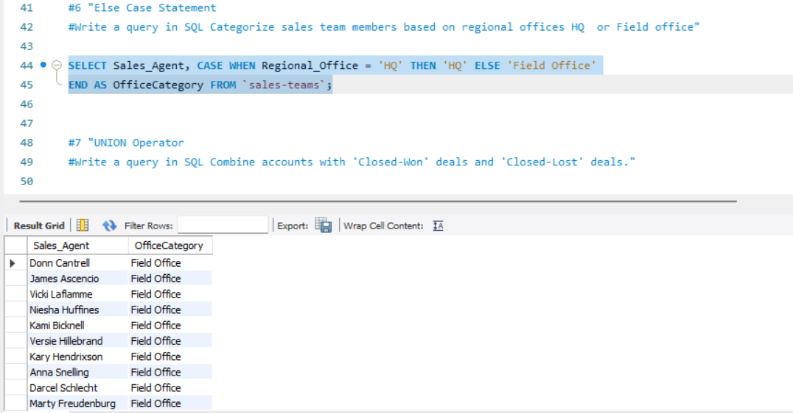

7 Write a query in SQL Combine accounts with 'Closed-Won' deals and 'Closed-Lost' deals."

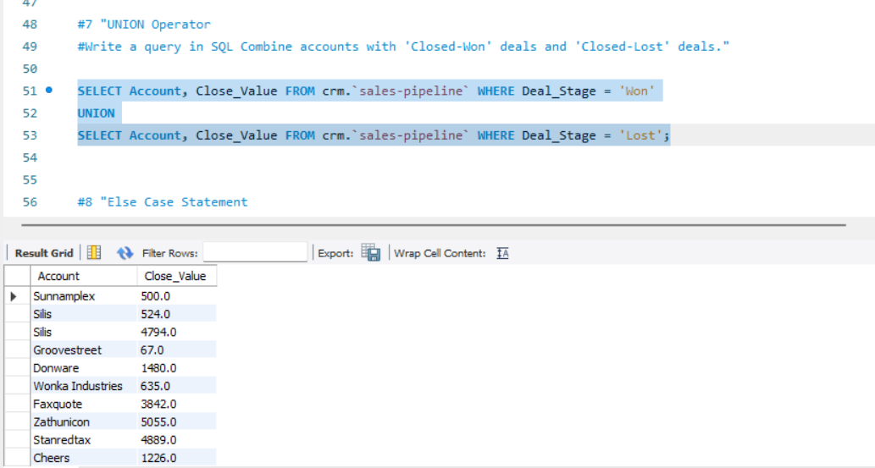

8 Write a query in SQL Categorize deal stages as 'High Value' or 'Low Value'"

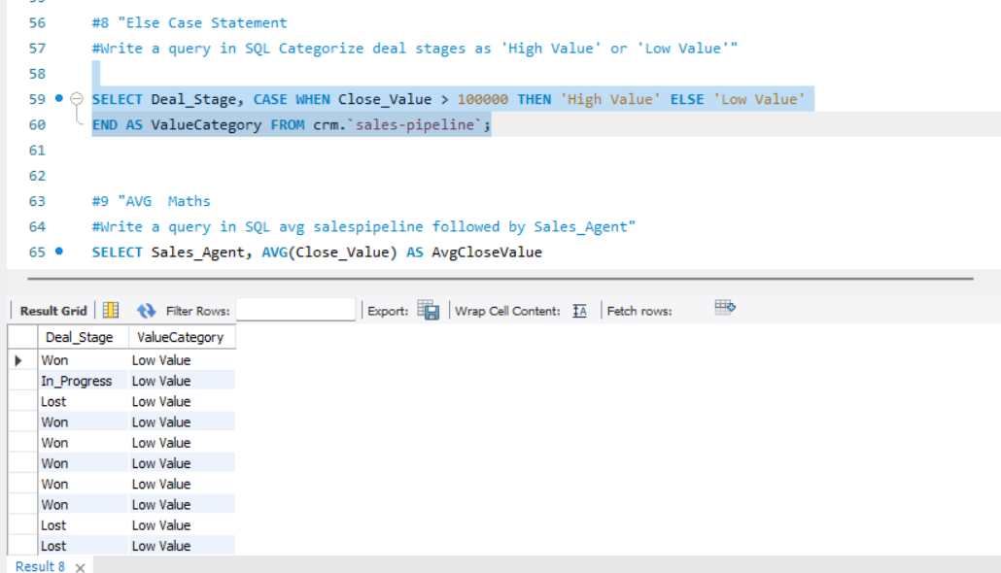

9 Write a query in SQL avg salespipeline followed by Sales_Agent"

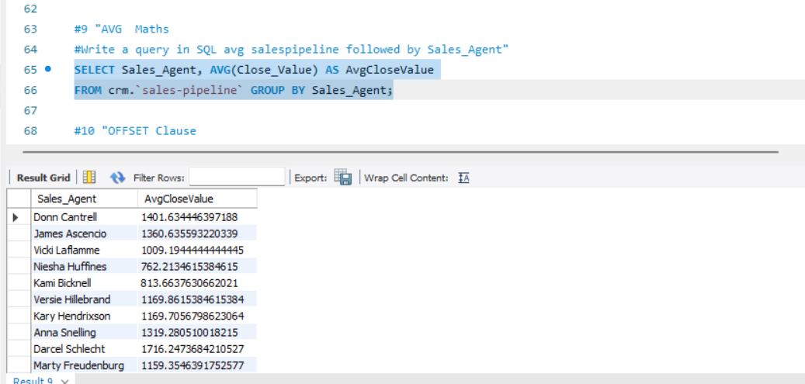

10 Write a query in SQL to find OFFSET of product followed by created date"

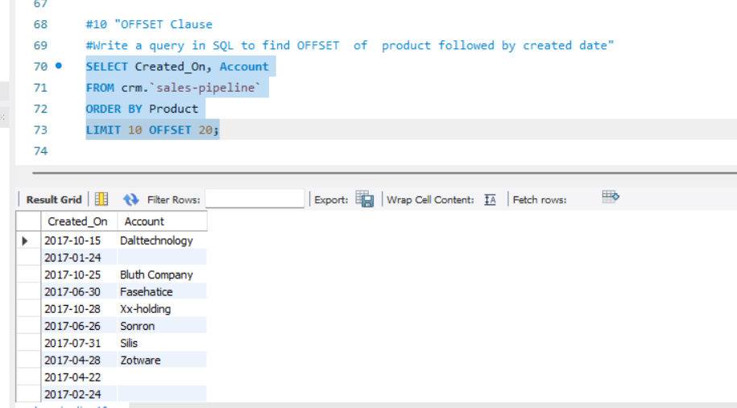

11 Write a query in SQL to find Lead and lag of Industry followed by created date"

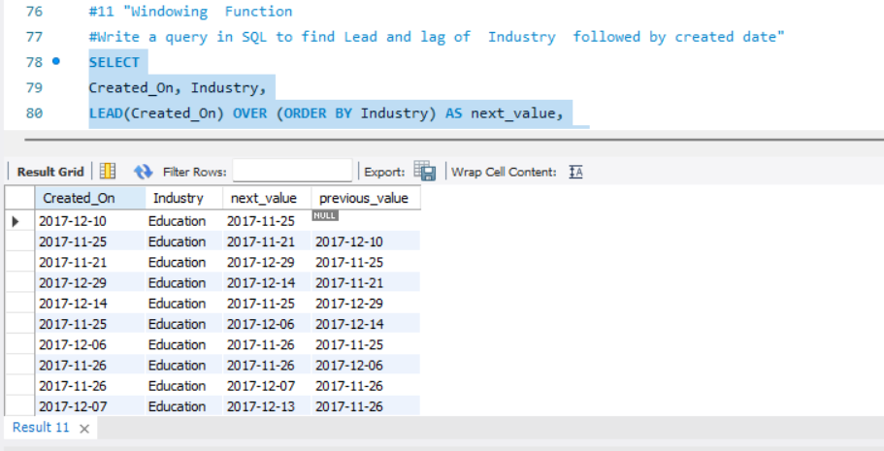

12 Write a query in SQL to FETCH Opportunity_ID, Sales_Agent, Product Followed by LIMIT 10, 5;"

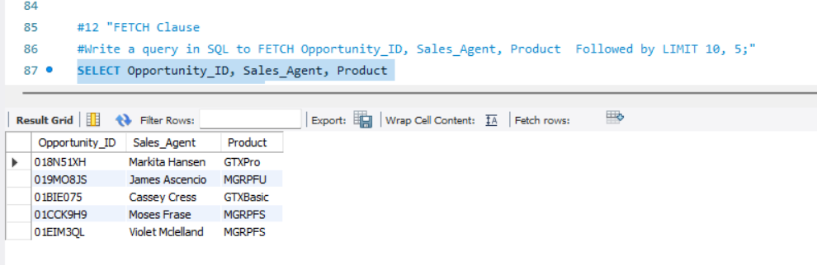

Files are uploaded on github

Link: <https://github.com/Snehal1915>